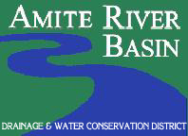
The Amite River Drainage and Water Conservation District (ARBC) regular meeting will be held on
Tuesday, May 16, 2023 at 10 am at Ascension Parish Council Chambers located at 607 E. Worthey Street, Gonzales, LA 70737.

The public is invited to attend.
You may type this link into a browser to watch the meeting via livestream: https://www.twitch.tv/amiteriverbasincomm or by going to www.amitebasin.org to click on the link.

AUDIENCE QUESTIONS AND COMMENTS: In compliance of Act 850 of the 2010 Regular Session, the District invites public input at meetings under line item(s) that require action by the Board. Non-agenda public comments are allowed with 3-minute time limits under the line item “General or Non-Agenda Public Comments.” There will be a 3-minute time limit per individual per meeting allowed for public comment, subject to a reduction of said time limit by the President if the total number of public speakers exceeds ten speakers. In accordance with the Americans with Disabilities Act, if you need special assistance, please contact Toni Guitrau at (225)296-4900 describing the assistance that is necessary.

